

Corvallis Benton County Economic Development Strategic
Plan

Updated July 2026



1
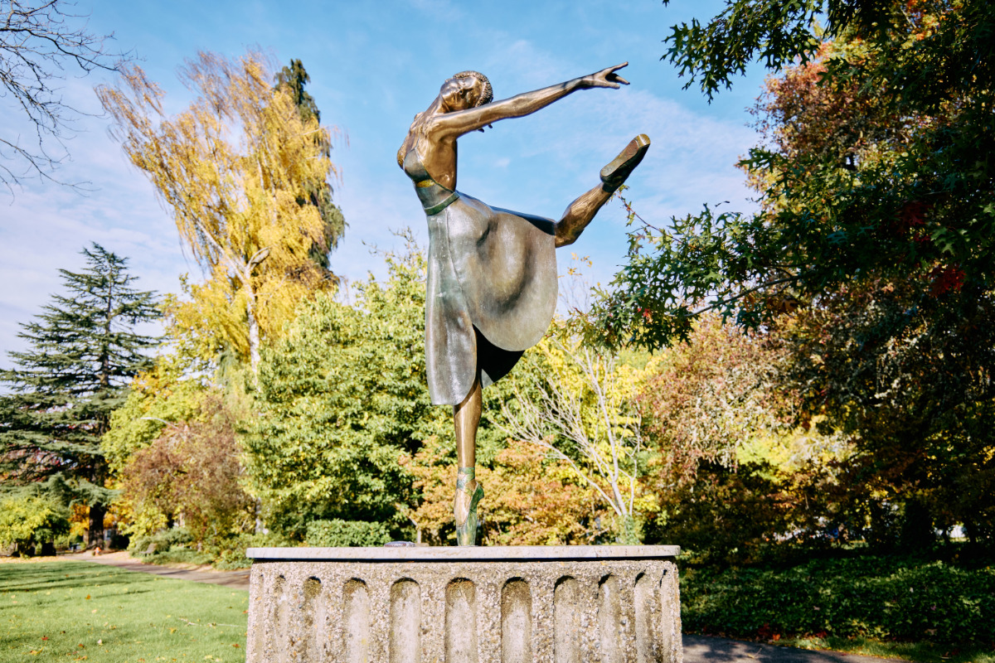


The Corvallis Benton County Economic Development office is a collaboration between the City of Corvallis and Benton County. Our office facilitates economic development in Benton County including Corvallis, Philomath, Adair, Alsea, Monroe, and North Albany. This plan is a long-range strategic tool that can be used as a living document to guide and facilitate economic development goals based on the needs of the City and County, its constituents and changing circumstances.
2

- Climate change
- Inflation
- Samaritan Restructuring / Consolidation of Healthcare Industry
- Tariff Policies
- Loss of Federally funded jobs
- Declining availability of federal grants
- Declining public school enrollment
- Challenging budget environment

Threats
- Support traded sector and target sector businesses with new and existing grants, loans, and incentives.
- Seek state and federal grant fund opportunities to leverage private investment and partnership.
- Effective marketing.
- Abundant available land for commercial and industrial development.
- Microfluidic and Mass Timber Tech Hubs at OSU.
- Community focus on economic development opportunities in Corvallis.
- Evaluate and make recommendations about land use policy and regulation reform that meets market demands.
- Strengthen partnerships aimed at supporting disadvantaged businesses and equity in access to resources.

Opportunities

- Environmental conditions such as contamination or wetlands that make some property difficult to develop.
- Power constraints
- High cost of public infrastructure to support development
- Limited resources from local governments to support development
- Access to affordable and reliable childcare.
- Railroad trestle collapse
- No regional SBDC Office as of 7/1/2026
- Housing unaffordability.

Weaknesses
- ATAMI / OSU Accelerator
- Highly educated workforce
- Major employers – Oregon State University/Samaritan/Hewlett Packard/2 Towns/Western Pulp/Natural Point/Nuscale
- Fareless transit system in Corvallis
- Good private and public school system
- Great walkability and community emphasis on sustainability
- Strong local and regional partners
- Vibrant natural and built environments.
- Local tools available for encouraging development.
- Support from elected officials and public for
economic development as a priority

Strengths
SWOT

3

3 Core Strategies for Corvallis-Benton EDO

Grow.

Strategy 1: Utilize new and existing tools such multi-unit property tax exemptions, enterprise zones, regionally significant industrial site designations, CPACE, TIF districts and public-private partnerships to grow the property tax base throughout Benton County.

Goal 1.a: Measure tax base growth in Benton County and report on how economic development programs are being utilized annually.

Active tax exemptions: Uncommon Cabinetry, Natural Point, Inc.

Table 1: Total Property Tax Imposed, Assessed Value, and Market Value in Benton County FY19-20- FY24-25
Fiscal Year | Total Market Value | Total Assessed Value | Total Tax Imposed | % Change in Total Tax Imposed
2024/25 | $21,001,293,000 | $11,132,486,000 | $198,513,000 | 3.17%
2023/24 | $20,206,138,000 | $10,776,944,000 | $192,406,000 | 3.91%
2022/23 | $18,551,250,000 | $10,362,793,000 | $185,164,000 | 4.94%
2021/22 | $15,958,042,000 | $9,990,464,000 | $176,437,000 | 5.15%
2020/21 | $15,133,874,000 | $9,545,994,000 | $167,802,000
Source: State of Oregon Department of Revenue Research

Table 2: Total Compression FY 20/21- 25/26
Fiscal Year | Total Compression Loss
2025/26 | $2,292,094
2024/25 | $2,212,584
2023/24 | $2,172,238
2022/23 | $2,295,275
2021/22 | $3,299,325*
2020/21 | $3,296,252*
Source: Benton County Tax Reports FY20/21-FY25/26 Table 6C
*Elevated totals due to Compression Loss of Local Option Levies for School District

4
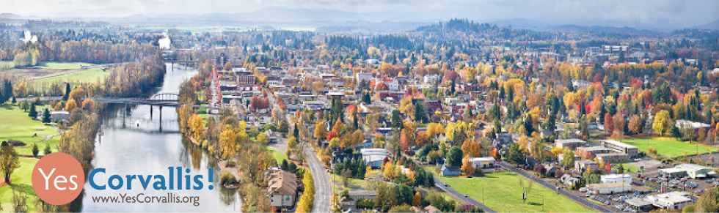

Goal 1.b: Effectively manage and encourage adoption of tools aimed at mixed use development, industrial development, and housing and assist with marketing those development opportunities for vacant and underutilized property.

Current Economic Development Toolkit:

Benton/Corvallis Enterprise Zone (HP, Sunset, and South Corvallis)
South Corvallis Urban Renewal District
Corvallis MUPTE Program
Downtown Corvallis Revolving Loan Fund Program
Countywide CPACE Program
Regionally Significant Industrial Sites program

Toolkit Utilization:

1 active Enterprise Zone tax exemptions – Natural Point
$250,000 South Corvallis URA Revolving Loan
2 active Multi Unit Property Tax Exemption – OBIE Companies, Pineview Development LLC
Downtown Revolving Loan Fund – 5 Active Loans, $40,000 currently available
2 CPACE Inquiries– No Active Loans

5
Goal 1.c: Effectively manage the Airport Industrial Park and market development opportunities to encourage new construction.

Annexation Application for 1,518 acres of city owned land comprising the Corvallis Municipal Airport and Industrial Park submitted on February 6th, 2026. The parcels available for lease and those currently under lease can be viewed on ArcGIS here: AIP - Leasable Land. Staff has also created a landing page for priority redevelopment sites on YesCorvallis.org to better market development opportunities. The City is working to establish a contract with a planning consultant to complete an Airport Overlay District required to accommodate the annexation. Due to ex parte rules, staff is limited in speaking publicly about the application until a public hearing opportunity.


Strategy 2: Manage a modern business retention and expansion program to support and grow traded sector businesses.

Goal 2.a: Benchmark, identify and recommend best practices for Industrial Land Use in Corvallis and Benton County

City Council has initiated Industrial Comprehensive Plan and Land Development Code text amendments and planning staff are working to establish a contract with a planning consultant to complete this task. EDO staff has researched comparator communities to identify areas for improvement within the Industrial zones. Provided below is a summary of those findings.

- The current Industrial Use Classifications are outdated and do not reflect current best practices, nor do agricultural use types.
- It is expected that the number of industrial comprehensive plan designations and zones can be further reduced or consolidated such as Limited Industrial- Office and General Industrial-Office. Expanding commercial use types within an “Industrial 1” or “Light Industrial” type zone and thinking about these areas within a form-based code methodology is under consideration. Three Industrial zones is typical among our comparators.
- The future of use of the now defunct railroad will be considered, and minimum lot size uses may be aimed at keeping commercial activities at scale to preserve larger lots. Industrial standards from residential and screening standards may be examined as well as the standards considered under nuisance characteristics.
- The dimensional requirements of all industrial zones should be reviewed.
- The Airport Industrial Park Development Plan standards need to be captured in the land development code to potentially retire the former planning document to eliminate redundancy.
6

Goal 2.b: Support businesses navigating the development review process and seek to provide grant and loan opportunities.

Business Retention and Expansion Service Metrics:

FY 25/26 - Q1: 24 Total
FY 25/26 - Q2: 24 Total
FY 25/26 – Q3: 52 Total
FY 25/26 – Q4: 64 Total

Table 4: BRE Service Metrics Q4 FY 25/26 Totals
Business Retention | 23
Business Recruitment | 8
Grant or Loan Application | 7
Event | 6
MUPTE | 5
Regulatory Assistance | 4
Site Selection | 4
Public Infrastructure | 3
AIP Lease | 1
CPACE | 1
Grant Administration | 1
MFU | 1
Source: Internal Tracking Data

Table 6: BRE Service Metrics FY 25/26 Totals
Business Retention | 38
Site Selection | 17
Grant or Loan Application | 17
Grant Administration | 16
Regulatory Assistance | 14
BROW | 13
MUPTE | 11
Business Recruitment | 11
MFU | 6
Event | 6
RSIS | 5
Public Infrastructure | 3
AIP Lease | 3
CPACE | 2
Enterprise Zone | 2
Source: Internal Tracking Data
7

Table 6: BRE Service Metrics FY 24/25 Totals
Grant or Loan Application | 43
Business Expansion | 31
Business Retention | 23
Business Recruitment | 14
Seeking Incentives | 13
BROW | 13
Regulatory Assistance | 13
Site Selection | 11
MUPTE | 8
Seeking Tenants | 7
Grant Administration | 5
AIP Lease | 4
Event | 4
Enterprise Zone | 3
Workforce Development Referral | 3
Infrastructure | 3
Other | 2
CPACE | 1
MFU | 1
Source: Internal Tracking Data

Goal 2.c: Work closely with Oregon State University Innovation Ecosystem to incubate innovative technologies and foster research commercialization to capture the long-term economic benefits for the local community.

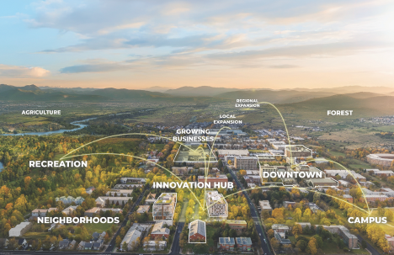
Staff are actively working with ATAMI and the Corvallis Microfluidic Tech Hub team to explore the possibility of leveraging an EDA grant for the buildout of SCALE Facility at the Airport Industrial Park that could host companies growing out of ATAMI. The primary barrier to this project is securing the 20% match required for the EDA grant and staff are exploring how the use of wetland mitigation credits, public private partnerships and state resources might help support the matching funds requirement.

Staff presented information about the Industrial Lands Inventory and site readiness to the Southern Willamette Valley Innovation Corridor Steering Committee on July 9.

8
Goal 2.d Leverage State and Regional partnerships with organizations such as Business Oregon that offer grant resources to document industrial land conditions and market those development opportunities.

Staff are delighted to share the approval of an application to designate 533 acres in South Corvallis including the Airport Industrial Park and several adjacent privately owned industrial properties in the Regionally Significant Industrial Sites Program. This makes South Corvallis the 13th RSIS in Oregon and the 7th largest statewide. Next steps involve preparing to identify priority public infrastructure projects, crafting development agreements, and preparing financing should an opportunity arise to utilize this new tool as an economic incentive. Staff also led the Opportunity Zone renomination process for three census tract applications in Corvallis during the last quarter and should find out the results of that application beyond end of year.

Goal 2.e: Conduct a survey regarding potential incentives and barriers. This data will help us assess the business climate and identify business needs, barriers, and opportunities and will be shared with EDC and Benton County.

The EDO has published a business survey and distributed it via the registry to more than 3000 businesses. Results will be provided at the next quarterly update.


Strategy 3: Bolster locally owned business and emerging sectors

Goal 3.a: Support Downtown Corvallis efforts aimed at placemaking, grant opportunities and establishing a Tax Increment Financing District to benefit local businesses and residents.

The Downtown Strategic Vitality Task Force Recommendations are set to be adopted by City Council on July 20 and EDO staff have followed the process closely to identify priority projects to be included in a Downtown Tax Increment Financing Plan and Report. The feasibility study for this plan and report is underway with boundaries for analysis to be established on the July 20 City Council meeting. A final report is expected in the fall of 2026, and a final plan and report should follow closely behind if City Council determines a district is feasible. Staff also continue to market and advertise the $40,000 remaining Downtown Revolving Loan Fund and regularly attend meetings with the Downtown Corvallis Organization to assist Main Street efforts, including the search for an Executive Director.
9
Goal 3.b: Collaborate with partners such as the various Chambers of Commerce, Visit Corvallis, and RAIN to provide services that support local businesses, workforce development and entrepreneurs.

Staff participated in number of events with regional partners during the last quarter, including:

April 27- Chamber of Commerce Business Forum Panel
May 13- Coffee with your EDO
May 15- Foreign Direct Investment Delegation
May 19- Cascade West Regional Wetland Consortium
May 26- Silicon Forest Partnership
June 29- Visit Corvallis Destination Experience Marketing Plan
July 1- Corvallis Planning Commission
July 7- LIFT Off EUG Showcase


Goal 3.c: Support initiatives and partnerships that benefit workforce development, childcare, and housing affordability.

Staff have continued to support the Experience Development Plan underway with Visit Corvallis following the RFP process that awarded a contract to secure a consultant. The EDO is also preparing a contract renewal with Visit Corvallis by 7/1/2026.

EDO Priority List: Based on the feedback from the Economic Development Coalition, Benton County Board of Commissioners, and Corvallis City Council.
10
SC URA Strategic Purchases | SC URA Infrastructure | Industrial Code Amendments
Office Zone Code Amendments | Legislative Relationship Building | Downtown Corvallis Tax Increment Financing
Financial Analysis of Taxable  Values and Incentives | WSVA Contamination | ED Marketing Program
Home Occupation Code Amendments | Alsea Revitalization Needs Assessment | AIP Public Private Partnership Strategy / Enterprise Fund
AIP Wetlands and Infrastructure Plan | Survey of traded sector and Downtown Corvallis businesses | Buildable Lands Inventory Economic Opportunities Analysis



Prioritization considerations:
- Impact – level and type of impact – long-term vs short-term, number of people affected, urgency, timeliness (current opportunity may not last), opportunity for synergy with other initiatives; from low to high.
- Timing/effort of implementation– Length and quantity of effort needed to implement; from longer-term to easily implementable.
Impact
Easily Implementable

Tier 2:
High Impact
Longer Implementation
Tier 2B:
Limited Impact
Faster Implementation
Tier 1:
High Impact
Easily Implementable
Low Priority:
Limited Impact
Lengthy Implementation

11
Priority Redevelopment Sites
The following sites are provided to indicate which projects could see prioritization in staff time but do not necessarily include all the opportunities we may pursue. This section can and will be regularly updated as priorities shift.

Airport Industrial Park

Area 1 consists of the Airport Ave frontage from HWY99 just past Ingalls where we are currently focusing a wetland delineation study and hope to apply advanced mitigation credits. Once this work is complete this area will be considered “shovel ready” and we can begin to actively market development opportunities.

124

South Corvallis Urban Renewal Area

The South Corvallis Urban Renewal Plan was adopted in 2018 and approved by voters in 2019. It was the first ever approved tax increment financing district in the City of Corvallis and followed many years of area planning and grassroots organizing. The tax increment financing district provides a funding mechanism to initiate a variety of improvements including but not limited to infrastructure, public-private partnerships, and non-motorized pedestrian improvements. There remains a significant number of vacant and underutilized commercial lots within this development area that could additionally benefit from the overlapping Enterprise Zone, which provides for up to five years of property tax exemption for new construction.

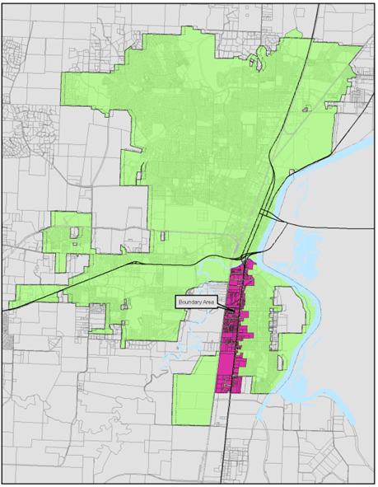

13
Seely Building – Adair Village
At more than 166,000 sq feet, the Seely Building in Adair Village is one of the largest industrial properties in Benton County and by far the largest vacant industrial property in the mid-Willamette valley. Known locally as “the Blockhouse”, this unique property has been home to a WWII barracks and later served as the Adair Air Force Station during the cold war. The property owner is willing to engage and negotiate price or discuss building renovations as needed. The property is zoned M-1 Limited Industrial and can accommodate a wide range of uses from light manufacturing, warehousing, wholesaling, assembly, processing, research and testing, so long as no emissions are potentially detrimental to public health or feature nuisance characteristics.

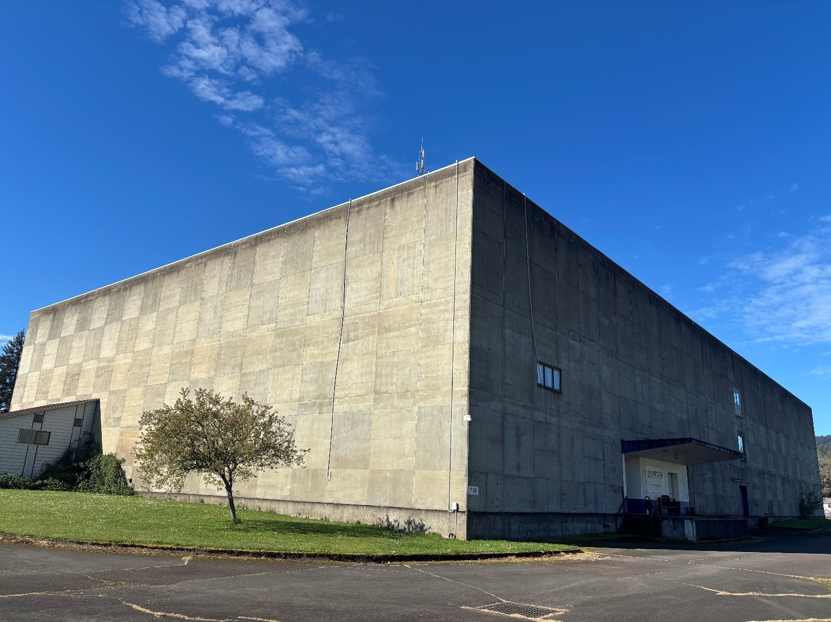

14

